TRASH COLLECTING ROBOT USING IOT TECHNOLOGY

**Methodology:**

The Trash Collecting Robot (TRASHBOT) is designed to address the growing issue of uncollected trash in public spaces, particularly in developing countries like India. The robot is equipped with an IoT interface and operates in both autonomous and manual control modes.

In autonomous mode, the robot navigates through its environment, using sensors and path planning algorithms to detect and avoid obstacles. It performs key tasks such as trash collection, segregation, and disposal. The robotic arm is used to pick up trash, which is then segregated into two categories—metallic and non-metallic—using a sorting mechanism. The segregated waste is stored in separate partitions within the robot’s bin.

In manual mode, the robot can be remotely controlled via the IoT interface, allowing the operator to guide it to specific areas as needed. When the trash bin reaches its capacity, the IoT interface sends a notification to the operator, alerting them to empty the bin.

TRASHBOT is designed to work autonomously for extended periods with minimal human intervention. It can adapt to changing environments and avoid harmful situations for humans, public property, and itself. However, like all machines, the robot requires regular maintenance to ensure optimal performance.

**Concept:**

The Trash Collecting Robot (TRASHBOT) operates through two modes: **Manual Mode** and **Autonomous Mode**, utilizing an Android mobile phone and a laptop for control.

**Manual Mode:**

In **Manual Mode**, the robot’s locomotion and trash collection are controlled via an Android phone using the **Blynk App**. The robot can be controlled from anywhere globally through the internet (IoT). For the robot’s vision, an Android phone is mounted on the robot, and live streaming is enabled using the **IP Webcam** app.

The trash collection is achieved through a robotic arm, which is powered by **3 servo motors**. Once the trash is collected, it is transferred to a trash bin attached to the robot platform. The trash bin has separate compartments for **metallic** and **non-metallic** trash. A **servo motor** rotates the bin to ensure the collected waste falls into its appropriate compartment.

**Autonomous Mode:**

In **Autonomous Mode**, the robot operates without human intervention. Initially, the robot is placed at the center of the workspace and follows a **coverage path planning algorithm** or **random path planning algorithm** to navigate the area. Trash detection is achieved using **4 ultrasonic sensors** arranged in two rows (2 sensors in each row), with a sensing range of up to 30cm to minimize crosstalk.

Using this configuration, the robot distinguishes between larger objects (e.g., walls), which are considered obstacles, and smaller objects, which may be trash. The robot avoids obstacles and collects the trash with its robotic arm.

Once trash is picked up, **metal detectors** embedded in the arm determine whether the trash is metallic or non-metallic. The waste is then sorted and deposited in the appropriate compartment in the trash bin.

An **ultrasonic sensor** placed in the trash bin monitors the waste level. If the bin reaches its full capacity, the operator is notified through the IoT interface.

**BLOCK DIAGRAM:**

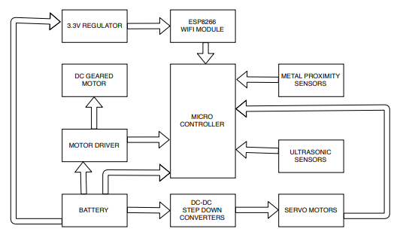

**COMPONENTS USED**

**1.Arduino Mega 2560 :** microcontroller board based on the ATmega2560  
                                  Buy this from here: <http://zipansion.com/3u6Xb>  
**2.Servo motors:**

ULTRA TORQUE DUAL SHAFT METAL GEAR 35KGCM CORELESS SERVO



This is the main servo which pulls the robotic arm up and down.

Buy this from here: <http://zipansion.com/3u6as>

HIGH TORQUE DIGITAL SERVO MOTOR 180° 20KGCM

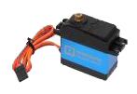

This servo is used to rotate the trashbin based on whether the picked up trash is a metal or nonmetal.

Buy this from here: <http://zipansion.com/3u6eK>

MG995 METAL GEAR SERVO 180 DEGREE ROTATION

[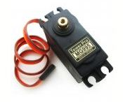](https://lh3.googleusercontent.com/6T1yDdaHmqQ5KV3ulvaForqz8CejtEbahDi57-5PjIHVpFbST6-a30SSrbJ7m4_owSJLWvf6wV2ulG1TP_bErHHCrUF-VEilCZe8na6TUDNV-g73FYhYv9h89xEHxwnzN32k_q9c)

2 of this servos are used to grab the trash by rotation of arm as shown in the video.

Buy this from here:<http://zipansion.com/3u6ha>

3.**LI-ION 11.1V 10000MAH (2C) WITH INBUILT CHARGER-PROTECTION**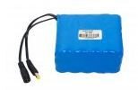

Buy this from here: <http://zipansion.com/3u6jq>   
This battey is capable of delivering 20A so that 5A can be utilized by each motor attached to the wheel.

4.**ESP8266 WIFI MODULE**

[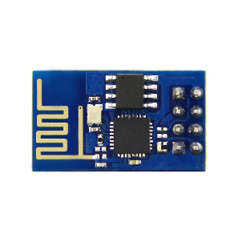](https://lh3.googleusercontent.com/U9VBTuj22mvH5QR6T5DUmgEaWvjJS8zis4d3NywGpR2FDUi5CLjIiQnTobujeF9QRNEC_1lQ_9n-iJEpwshE9fNGHDzofZfXGh7b3HNNYEIwvJ6C8Gu8nt8HJ-Qk7yXPihaBtQIK)

Buy this from here: <http://zipansion.com/3u6oZ> used to provide wifi and internet facilities to the microcontroller.

**5.LM1117 3.3V OUTPUT BREAKOUT BOARD BREADBOARD POWER SUPPLY**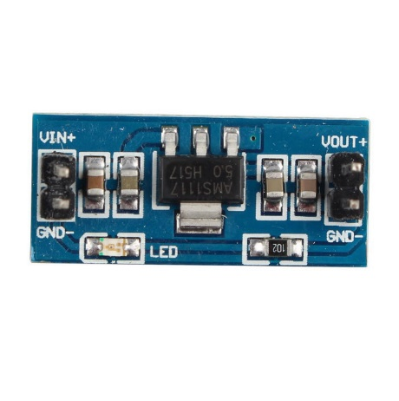

ESP8266 is strictly specific in its voltage rating of 3.3V. LM1117 is used to serve this purpose.Connecting ESP8266 directly to the arduino's 3.3V supply might not serve the amperage needs.

Buy this from here: <http://zipansion.com/3u6r7>

**6.STEP DOWN DC-DC ADJUSTABLE VOLTAGE REGULATOR** used to stepdown the battery's voltage to the required voltage of servo motors.

STEP DOWN DC-DC ADJUSTABLE VOLTAGE REGULATOR 5A (XL4015E1 BASED)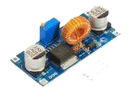

Buy this from here:<http://zipansion.com/3u6t3>

STEP DOWN DC-DC ADJUSTABLE VOLTAGE REGULATOR 3A OUTPUT

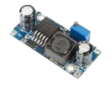

Buy this from here:<http://zipansion.com/3u6w0>

**7.DUAL DC MOTOR DRIVER**

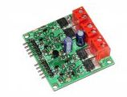

the **function of motor drivers** is to take a low-current control signal and then turn it into a higher-current signal that can **drive**a **motor**.It can also change the rotational direction of a motor.

Buy this from here: <http://zipansion.com/3u6yK>

**8.USB TO TTL MODULE**

[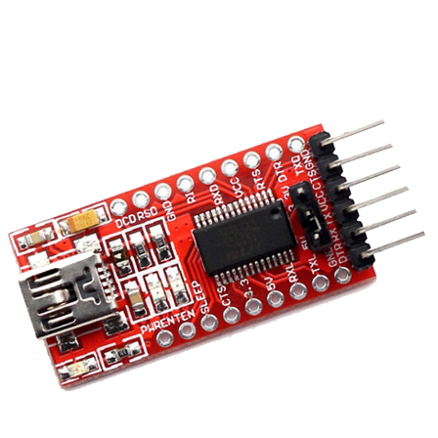](https://lh5.googleusercontent.com/B2MrMwHalBQL63erfmYih1amMOQZ7jFx4uW9y4drGgURw5A7VJ8ppNVGPFuauz-t6VlNswQMFx6JU5ibgoLIo4saD8E96aDWHrGMGlZ250hzJXgEAfz4FGdeXfBIYpJqboWMSJqr)

used to flash esp8266 wifi module with the latest blynk compatible firmware.

Buy this from here: <http://zipansion.com/3u72L>  
Refer to this video for knowing how to flash ESP8266 with latest blynk compatible firmware :<http://zipansion.com/3u75O>

**9.METAL PROXIMITY SENSOR**

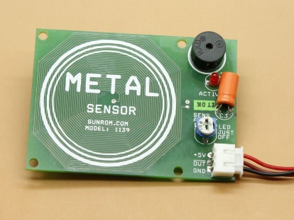

used to check whether the trash picked up is a metal or nonmetal.

Buy this from here:<http://zipansion.com/3u78u>

**10.ULTRASONIC SENSOR**  
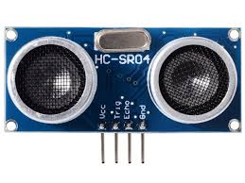  
used for detecting trashes and obstacles.  
Buy this from here: <http://zipansion.com/3u7Cl>

**SOFTWARES USED**  
**1.BLYNK ANDRODID APP:** for IOT connectivity.

Blynk is a Platform with iOS and Android apps to control Arduino, Raspberry Pi and the likes over the Internet.

 Blynk will get you online and ready for the **Internet Of Your Things**.

There are three major components in the blynk platform:

**Blynk App** - allows to you create amazing interfaces for your   projects using various widgets we provide.

**Blynk Server** - responsible for all the communications between the smartphone and hardware. You can use our Blynk Cloud or run your [private Blynk server](http://blynk-server/) locally. It’s open-source, could easily handle thousands of devices and can even be launched on a Raspberry Pi.

**Blynk Libraries** - for all the popular hardware platforms - enable communication with the server and process all the incoming and outcoming commands.

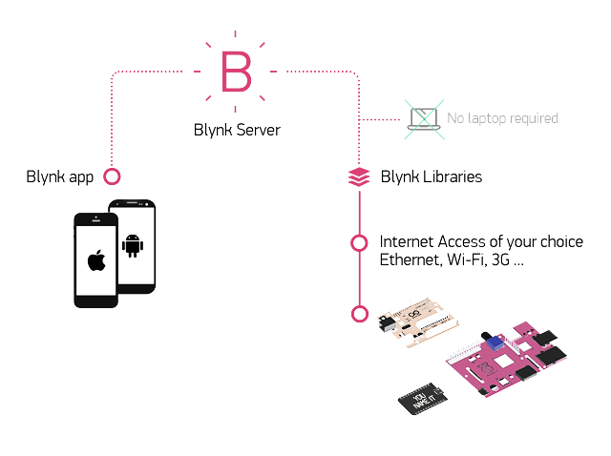  
**2.ARDUINO IDE:** for programming the audio **3.IP WEBCAM ANDROID APP:** for live streaming. **4.ESP8266 FLASH DOWNLOADER:**for flashing ESP8266 with blynk compatible firmware.  
  
  
  
**IOT INTERFACE**

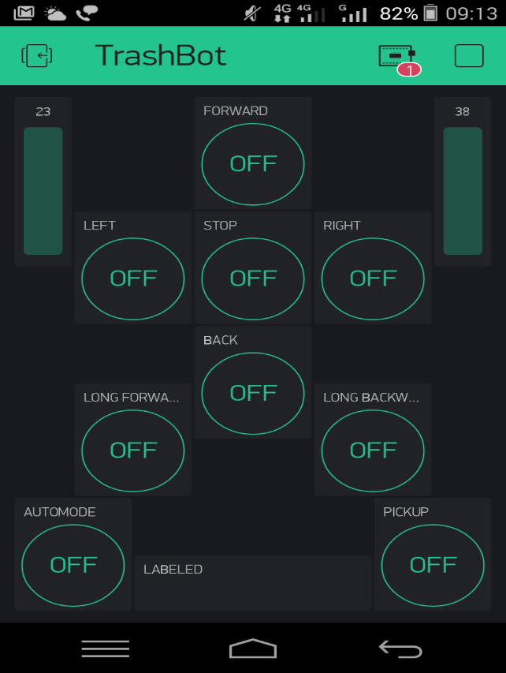

**FLOW CHART**  
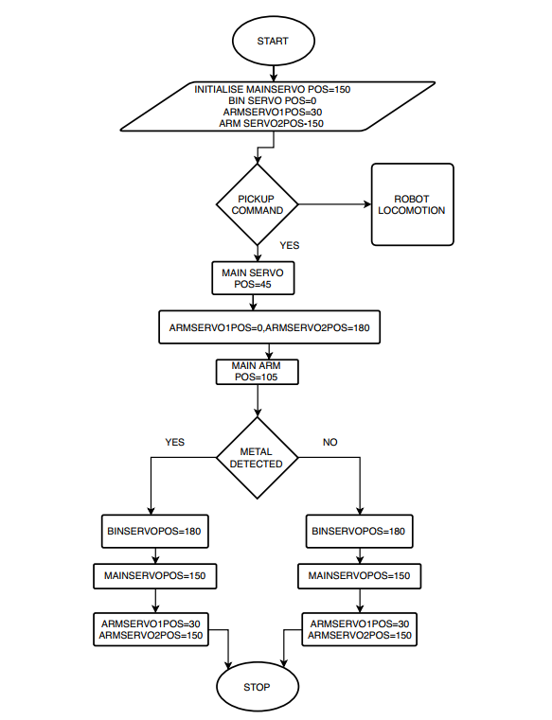

**MECHANICAL MODEL**  
  
**ROBOTIC ARM**

The movement of the arm is made possible using 3 servos(35kg-cm,2x15kg-cm)

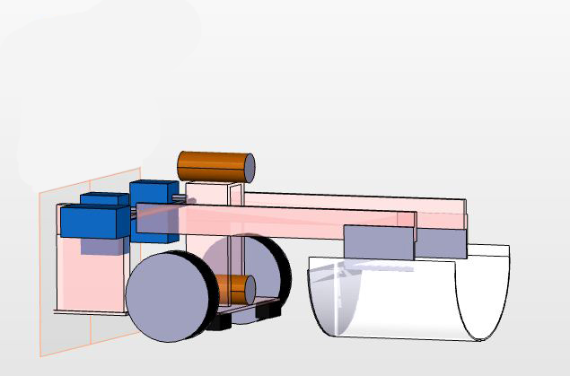  
  
  
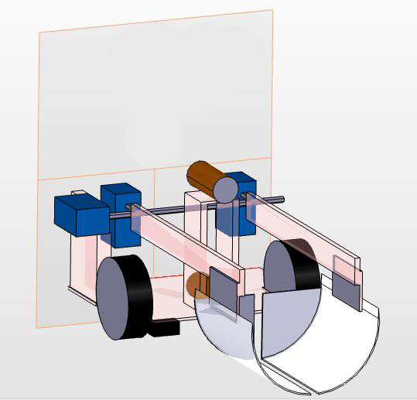

**CHASSIS MODELLING -4 WHEEL DRIVE ROBOT DESIGN**

Here we use differential steering method.

Differential Steering is nothing but creating difference in the speed of the adjacent left or   
right wheels to take turns.  
 For a complete 360 spin at its pivot position the two wheels on each adjacent side (left and right )   
must rotate on opposite spin at same speed.   
This approach might appear easy, but it is not always efficient with all kinds of 4 wheel chassis.

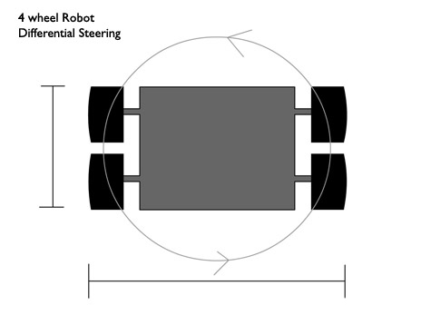

In this design when the robot takes a zero-radius 360 degree turn (pivot turning), the front wheel  
 gives almost negligible resistance to the overall circular motion generated by the rear wheels.   
Hence the torque applied by motors on each wheels gets properly harnessed,  
 resulting in better performance without any drag or wheel slip while taking turn.  
 Notice that turning of the body is not dependent on the wheel slips any more.   
Even if we add motors across all the 4 wheels, the result would be still better than other designs.  
 Hence in this design you would not require omnidirectional wheels, or tank like wheels,   
a set of ordinary rubber wheels would do just fine (cost saving).

Some of the advantages that you get is out of this design are :  
- No loss of torque, fast turning, no wheel slips while turning, better traction on wheels,   
cost saving by use of regular wheels.

**CIRCUIT DIAGRAMS**  
**1.ESP8266 flashing circuit**

   Components: AMS1117 voltage regulator,USB to ftdi module

    mini usb b cable,9v battery

   Software: ESP Flash downloader

TX ESP8266-RX USB TO FTDI

RX ESP8266-TX USB TO FTDI

CH_PD ESP8266-VCC

GPIO 0-GND

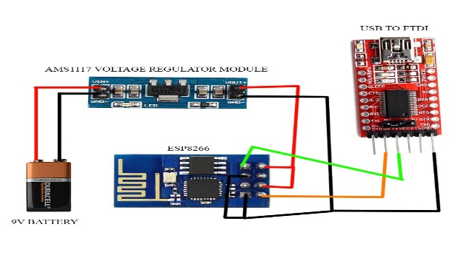

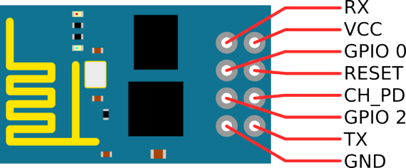

**2.ESP8266 with arduino mega**

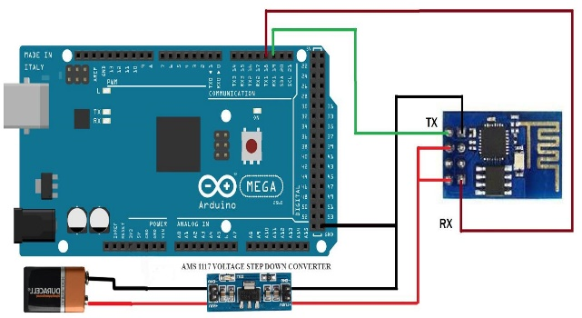

To avoid ESP8266 resets a decoupling capacitor 0.1uF is placed between VCC and GND of esp8266

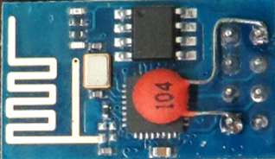  
**3.Servo motor with arduino**  
  
The movement of the arm is made possible using 3 seros(35kg-cm,2x15kg-cm)

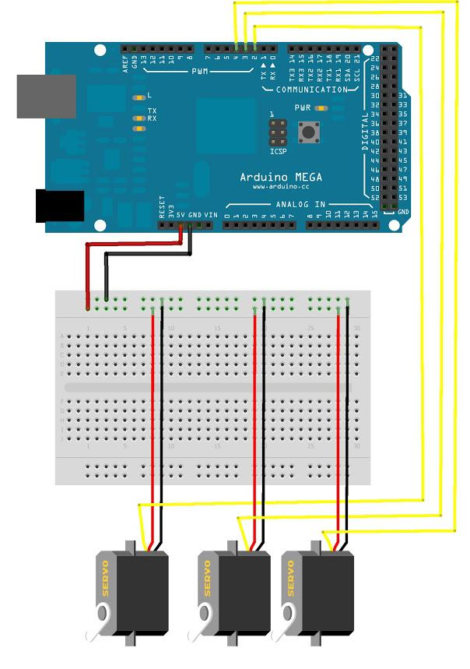

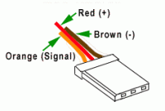

**4.Arduino with ultrasonic sensor**

[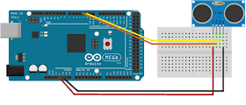](https://blogger.googleusercontent.com/img/b/R29vZ2xl/AVvXsEjFskoPyCl3pvtlsQQUfroGFj0cXMlAKuven6iRfifNkfrI5TIDMDXjYbAk1PxpsKGnJfBSJx_Jjhm6lsWnofleG9f7_EtHr7JcAREz6n2wuRpZTOSR954pgufqVGTyJ_73t9yrcZ19OYBD/s1600/Picture1.png)

**5.DC geared motor-Arduino-Motor drive**

[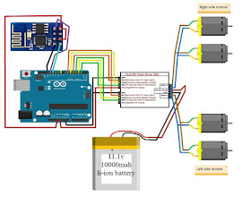](https://blogger.googleusercontent.com/img/b/R29vZ2xl/AVvXsEgYpOMaJEWUvymrHsIwADmrOSfhCrGaZyeBg1UpH0bs5IhGB04-m8J_VLh44jN9UDmcBknyh4gPtHUdNiad_IEF6SMnb4MrNO3yY37MygaB8ubnp_Rc5G1UeGJ_1OxmZo1OJC39f5Kl8dGb/s1600/Picture2.jpg)

**6.Arduino with metal proximity sensor**

[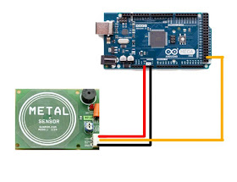](https://blogger.googleusercontent.com/img/b/R29vZ2xl/AVvXsEi566mki1JhZDobyJeMLYiFjamBqNWbrtAVhZquEQ3HI593wl4tj15G6YL6sz7PZFn5o6TTkIAfPyW7b8FzViaAnMfEpWw1zefisX6Crjh3KBVC2bvGGNJJTbIpVLYYzQbcayYxyykEnLbq/s1600/Picture3.jpg)

**PROGRAM CODE**

Click on this link for program code : <http://zipansion.com/3u7J9>